LAST Resource Inventory Detail

Arizona
Three trailers with the following equipment:
- Coffin stand
- Wooden platform
- Wooden stairs
- Carpet rolls
- Step ladder
- Fabric steamer
- Bunting
- Bow maker
- Gloves
- Mourning bands
- Pike poles
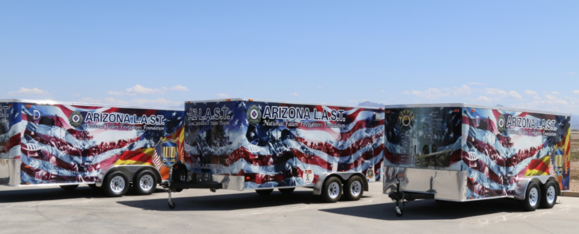
- Axes
- Ceremonial bell
- Saw horse barricades
- Flags
- Umbrellas
- Chairs
- Misc items

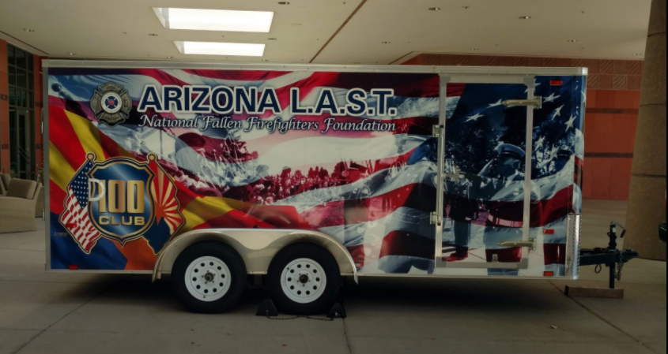
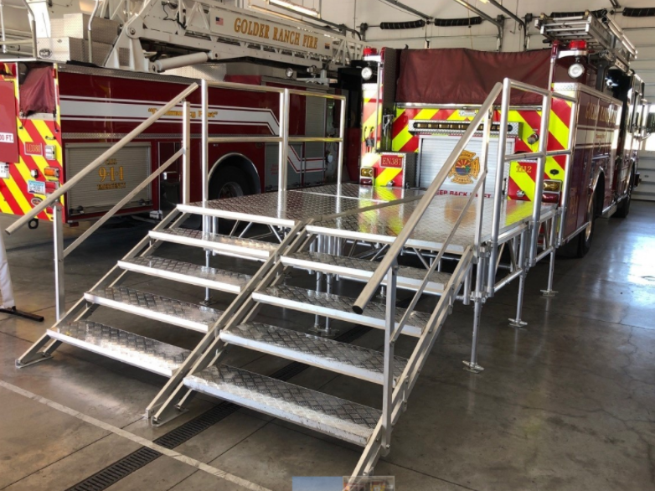

Connecticut
One trailer with two caskets and several sets of color guard equipment.

Florida
One trailer with the following equipment necessary to plan and execute a full LODD funeral:
- Planning supplies (charts, clipboards, checklists and written resources)
- Supply of generic FD dress uniforms in various sizes to allow select members of the affected department to be outfitted if they do not have a Calss A
- Color guard equipment
- Practice casket
- Casket flags
- Mourning bands
- Dress gloves
- Bunker gear display stand
- Portable PA system
- Pop up tents
- 2-way radio set(10) with earpieces
- Bunting
- Ceremonial bell
- Garrison flag
Georgia
One trailer with the following equipment
- Class “A” uniform loaner program which includes uniforms, shoes etc.
- Flags, flag cases, paws, flag poles
- Funeral items like axes etc.
- A portable radio system
- Some display items
- Can include practice casket

One refurbished 2003 caisson engine with a pneumatic lift in the hose bed
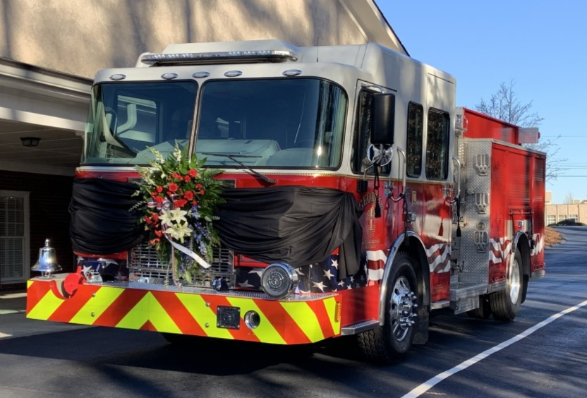

Indiana
One Mobile Operations Center (Command Post)
- extensive communications capabilities
- meeting room
- work spaces
- exterior scene lighting
- 40’ telescoping mast with a remote-controlled PTZ camera for scene or parking lot monitoring.

One large trailer
- Two very nice six-passenger golf carts
  - great resource during the planning phase at cemeteries and funeral venues
  - shuttling people (particularly handicapped) on the day of the event
- Traffic cones and other barriers for traffic control as well as multiple stanchions for people-control and establishing visitation lines
- 30’ x 50’ and 30’ x 60’ garrison flags
- Commercial-grade FM transmitter that we use to broadcast recorded instructions via civilian/commercial FM radio as vehicles arrive for a funeral, etc. (As they approach the venue, they are instructed via Variable-Message Boards to tune to the appropriate frequency.)

Battery-powered wireless sound systems with sound boards/mixers, multiple microphones, stands, podium, etc.

Commercial-grade wired/wireless live-streaming equipment. It enables us to live-stream funeral services from churches and other venues as well as from cemeteries. It uses redundant transmission paths (wired; wi-fi; Verizon; AT&T; and T-Mobile) to minimize the possibility of dropouts. The redundant signals are sent to the cloud where they are continually parsed and the strongest/clearest is then streamed to the appropriate platform(s) – agency website, Facebook, YouTube, etc.

Michigan
One trailer

One 1937 Seagrave Safety Sedan / Memorial Rig

Minnesota
Two trailers
One trailer with
- Gear rack
- Flags
- Small stage
- Several pop up canopies
- Misc items

One trailer with
- 350 plastic folding chairs
- 10 five foot round tables

Missouri
Five trailers with the following equipment:
- 2 – 20X30 flags
- Parade flag sets
- Portable PA systems that integrate with each other (to build larger system)
- Traffic Cones
- Pike Poles, Ax, Bell
- Casket Roller box (goes in engine to roll casket into)
- Riser
- Bunting for stations and apparatus

Nebraska
One trailer with flags, bunting, tools, practice casket, signs etc.

New Hampshire
Two trailers
One equipment trailer with the following equipment:

- 2 Sound system
- 3 practice caskets
- Helmets of each color for presentations
- Full set of turnout gear for presentation
- Gear stand
- Podium
- Bell for 555
- Complete set of items for uniform repair
- Ironing board and iron
- Umbrellas
- 2 generators
- 100 dozen white gloves
- Mourning bands
- Bunting
- Black mourning cloths
- Flags
- 20-‘ x 30’ garrison flag
- Banker (people mover chains) for large events
- Backdrops
- Church truck
- Wheel chair
- Trumpet
- Honor guard flags
- Casket flags
- Presentation boxes
- Easels
- Kleenex
- Much more items……

One stage trailer with two 8 x 8 staging systems
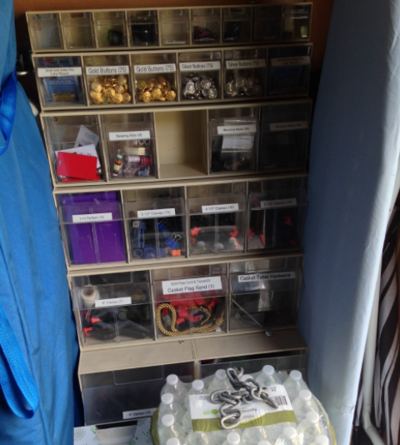
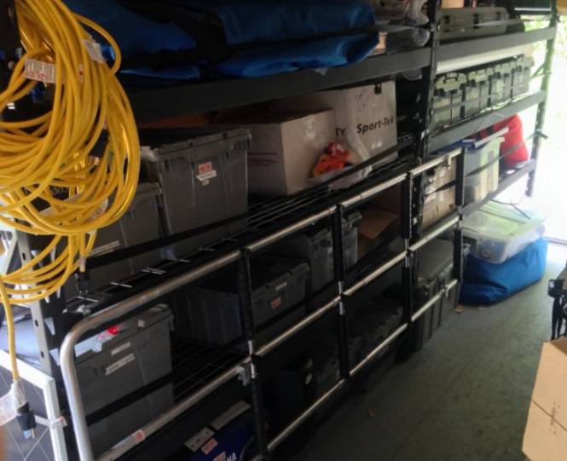
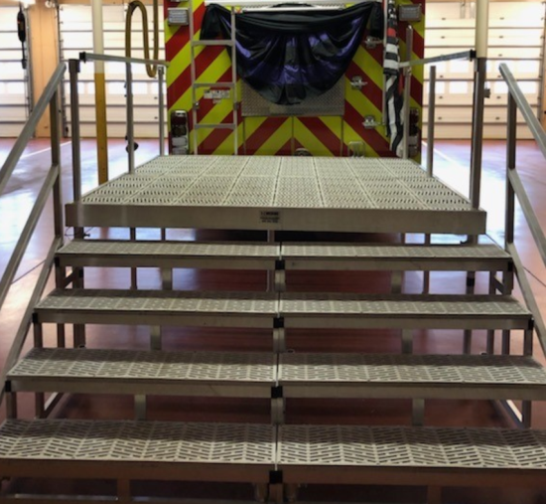
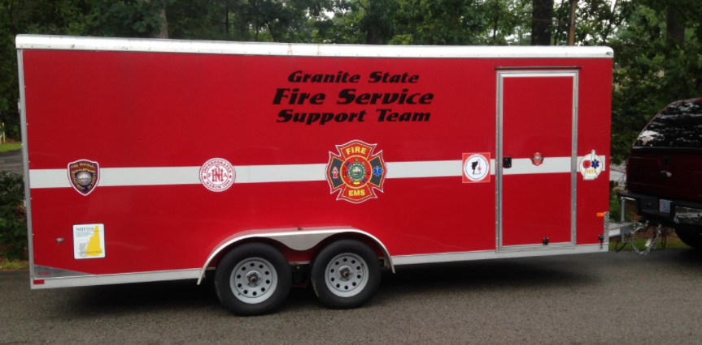
Ohio
One trailer with the following equipment
- Steps and platform for loading a casket on an engine.
- Practice casket
- Bunting for 3 engines
- Rollers Mounted on a plywood sheet that can be put into a hose bed
- Extra hitch ball
- Setup directions
- Extra zip ties

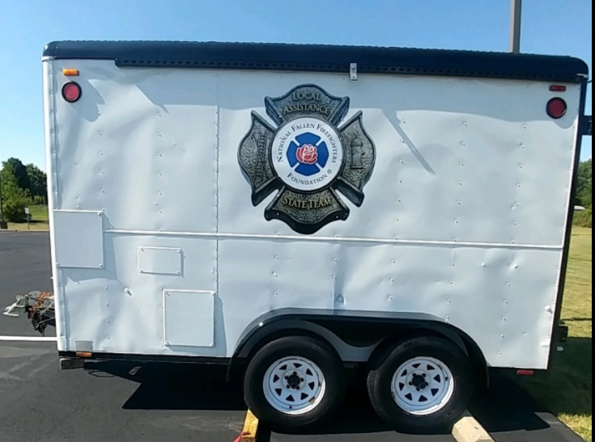

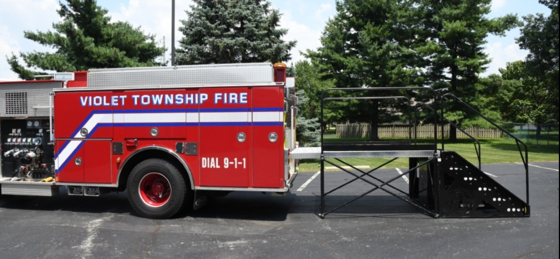

Rhode Island
One trailer with the following equipment
- Steps and platform
- 20+ pieces of bunting
- 1,000+ gloves in various sizes
- Mourning bands
- Several flags
- Axes
- Pike poles
- Bell
- Stand alone PA system and generator

Virginia
One trailer with steps

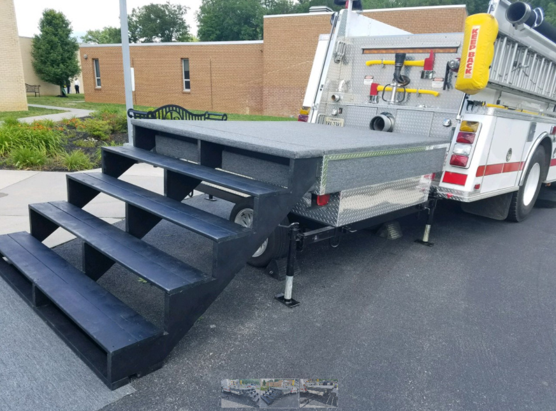
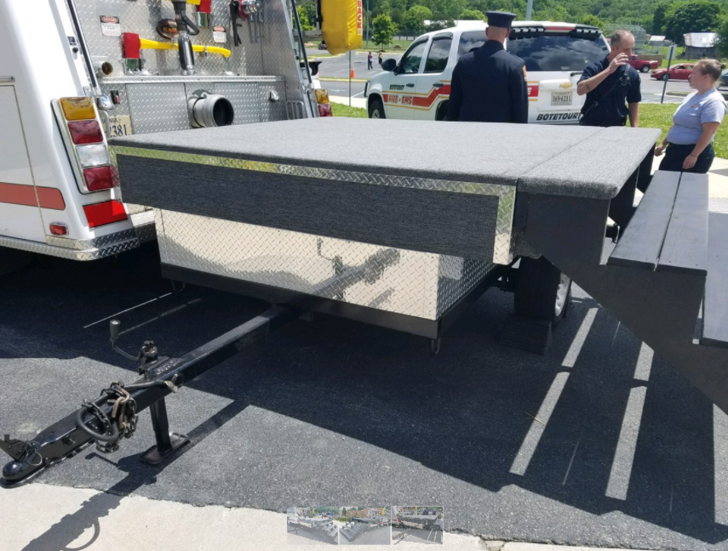
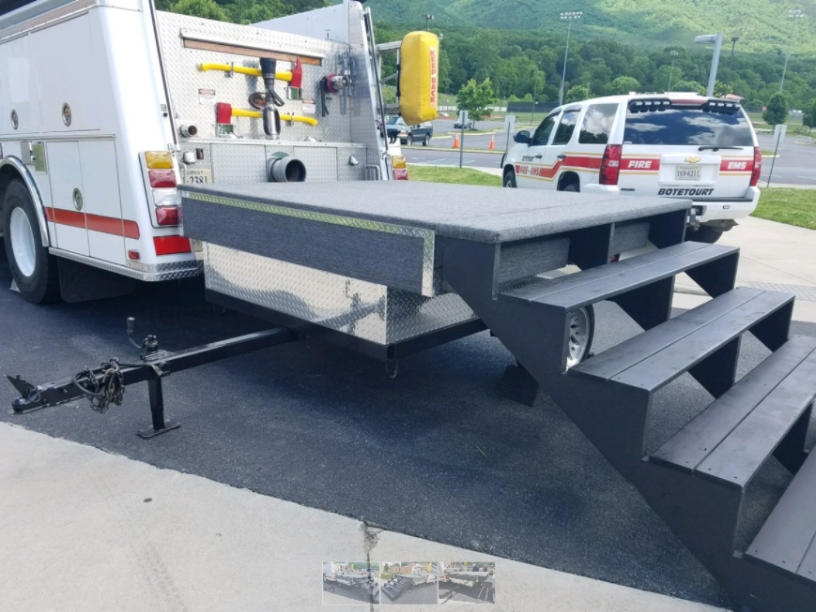

Washington
One trailer with the following equipment:
- Easels
- Table cloths
- Pike poles
- Bell
- Bell table
- Urn table
- Miscellaneous items

Wyoming
One trailer with the following equipment
- Casket stand and ramp
- Bunting
- 4 – 5 X 9.5 foot cloth flags
- 1 set pike poles (2)
- 1 set axes (2)
- Flag holsters (4)
- Flag toppers: 1 Maltese Cross, 1 Eagle, and 2 Pointed Spear
- Assorted white gloves (box)
- Badge bands
- Casket bands – 2 sets
- Bell
- Table and chairs
- Garment stand
- Candlestick markers (20)
- Garrison Flag – (1) with chord and rope
- 4 flag stand bases and 4 flag poles
- 10 umbrellas
- 2 baskets (for cards)
- 1 urn

