LAST Resource Inventory Detail

Arizona
Three trailers with the following equipment:
- Coffin Stand (diamond plate, called a “caisson” by some members) ~ 1 each
- Aluminum Platform (placed behind an engine that will carry the fallen) ~ 2 each
- Aluminum Stairs (for platforms) ~ 2 each
- Folding Step Ladder (small, 3 step) ~ 1 each
- Electric Fabric Steamer (stored in a plastic tub) ~ 1 each
- Bunting, various lengths, sizes and styles (stowed in a plastic tub)
- Bow Maker (stored in its cardboard box) ~ 1 each
- White "Class A" Gloves ~ a supply, approximately 20 to 30 pairs
- Elastic Mourning Badge Bands ~ some number, currently about 20 each
- Chrome Honor Guard style Pike Pole with case ~ 2 each
- Chrome Honor Guard style Pickhead Axe with case ~ 2 each
- Chrome Ceremonial Bell (stowed in a plastic box) ~ 2 each
- LAST Team Stand-up Banner (blue case) ~ 1 each
- "Easy Up" Wall Panels (black cases) ~ 3 each
- Display Board Easel (black case) ~ 1 each
- Wooden Easels ~ 2 each
- Plastic Equipment Tub (holds misc equipment ~ see below)
  - Extension Cord ~ 1 each
  - Small, Foldable, Tripod Easels ~ 6 each
  - Elastic Coffin Flag Straps ~ 2 each
  - Garmin GPS Device with Dash Mount ~ 1 each
  - Black Plastic One Use Table Covers 54"x108" ~ 4 each
  - LAST Team Property Stickers (sheets) ~ 2 sheets left
- Plastic Equipment Tub (holds misc equipment ~ see below)
  - FF Mass Cards and Sign-in Book ~ 3 each
  - PSOB Benefit Pamphlets ~ unknown number
- Plastic Storage Tub ~ Misc Office Supplies
- Plastic Equipment Tub (holds misc equipment ~ see below)
  - Packing Tape Dispenser ~ 1 each
  - Packing Tape (refill rolls) ~ 1 roll
  - Adjustable Wrench ~ 1 each
  - Tape Measures ~ 2 each
  - Trailer Landing Foot/Plate ~ 1 each
  - Green Tie Down Straps ~ 2 each
  - Small Yellow Plastic Wheel Chocks ~ 2 each
  - Brown Cloth Hand Towels ~ 2 each
  - Metal Screws (box) ~ 1 box
  - Razor Knife ~ 1 each
  - Diagonal Wire Cutter Pliers ~ 2 each
- Broom ~ 1 each
- Plastic Ice Chest / Cooler (red, white) ~ 2 each
  - Vinyl Lunch Coolers (inside ice chest) ~ 2 each
  - Plastic Water Jugs (inside ice chest) ~ 2 each
- Soda, Water Cooling Tub (round, blue) ~ 1 each
- Large American “Garrison” Flag and hanging cables (in plastic tub) ~ 1 each
- Trailer Hitch with 2 5/16" Ball ~ 1 each
- Backup Trailer Hitch with 2 5/16" Ball ~ 1 each
- Four-way Lug Wrench ~ 1 each
- Small Floor Jack ~ 1 each
- Umbrella, golf style ~ 4 each
- Umbrella, compact, collapsible ~ 6 each
- Steel Folding Chair ~ 4 each
- 6 foot Folding Table ~ 1 each
- Battery Lanterns ~ 2 each
- Misc. Tie-Down Straps and Bungie Cords ~ 6 to 10 each
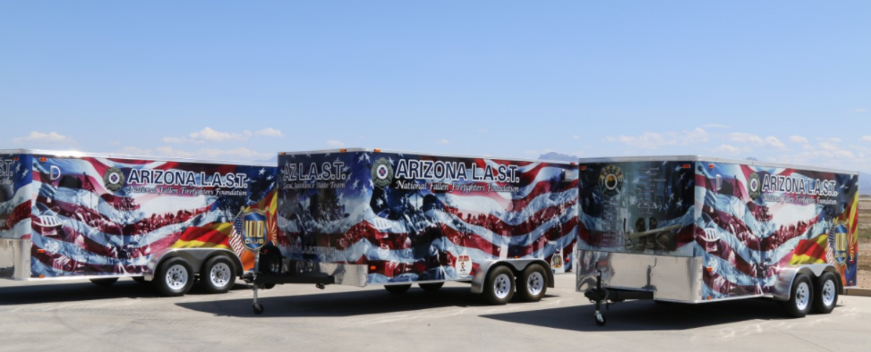
- Cases of Bottled Water ~

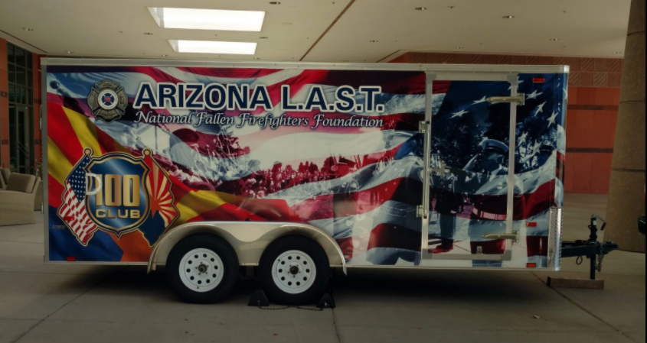
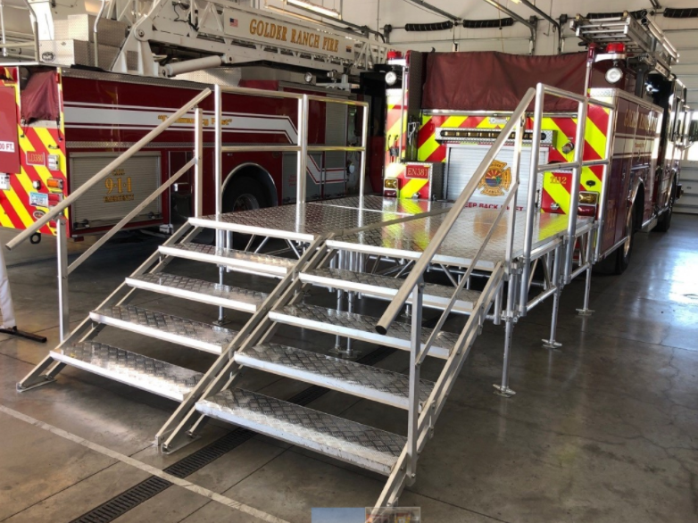
Connecticut
One trailer with two caskets and several sets of color guard equipment.

Indiana
One Mobile Operations Center (Command Post)
- extensive communications capabilities
- meeting room
- work spaces
- exterior scene lighting
- 40’ telescoping mast with a remote-controlled PTZ camera for scene or parking lot monitoring.

One large trailer
- Two very nice six-passenger golf carts
  - great resource during the planning phase at cemeteries and funeral venues
  - shuttling people (particularly handicapped) on the day of the event
- Traffic cones and other barriers for traffic control as well as multiple stanchions for people-control and establishing visitation lines
- 30’ x 50’ and 30’ x 60’ garrison flags
- Commercial-grade FM transmitter that we use to broadcast recorded instructions via civilian/commercial FM radio as vehicles arrive for a funeral, etc. (As they approach the venue, they are instructed via Variable-Message Boards to tune to the appropriate frequency.)

Battery-powered wireless sound systems with sound boards/mixers, multiple microphones, stands, podium, etc.

Commercial-grade wired/wireless live-streaming equipment. It enables us to live-stream funeral services from churches and other venues as well as from cemeteries. It uses redundant transmission paths (wired; wi-fi; Verizon; AT&T; and T-Mobile) to minimize the possibility of dropouts. The redundant signals are sent to the cloud where they are continually parsed and the strongest/clearest is then streamed to the appropriate platform(s) – agency website, Facebook, YouTube, etc.

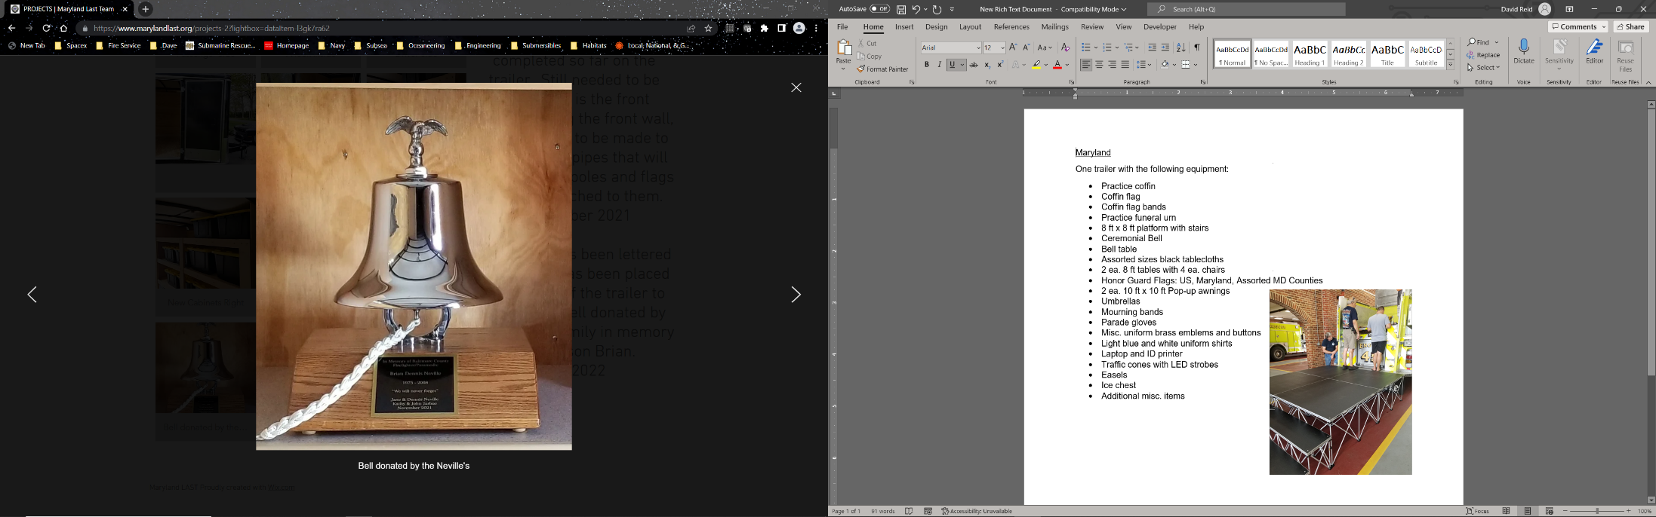
Maryland
One trailer with the following equipment:
- Practice casket
- Casket flags
- Casket flag bands
- Practice funeral urn
- 8 ft x 8 ft platform with steps
- Ceremonial Bell
- Bell table
- Assorted sizes black tablecloths
- 2 ea. 8 ft tables with chairs
- Honor Guard Flags: US, Maryland, Assorted MD Counties
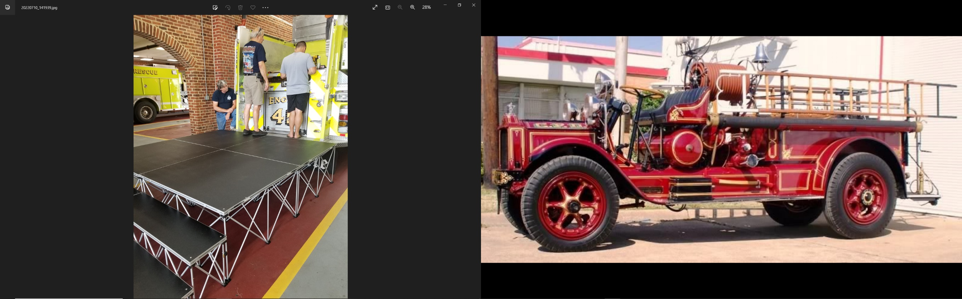
- 2 ea. 10 ft x 10 ft Pop-up awnings
- Umbrellas
- Mourning bands
- Parade gloves
- Misc. uniform brass emblems and buttons
- Light blue and white uniform shirts
- Laptop and ID printer
- LAST resource library
- Traffic cones with LED strobes
- Easels
- Ice chest
- Additional misc. items

Michigan
One trailer

One 1937 Seagrave Safety Sedan / Memorial Rig

Minnesota
Two trailers
One trailer with
- Gear rack
- Flags
- Small stage
- Several pop up canopies
- Misc items

One trailer with
- 350 plastic folding chairs
- 10 five foot round tables

Missouri
Five trailers, each with the following equipment:
- 2 – 20X30 flags
- Parade flag sets
- Portable PA systems that integrate with each other (to build larger system)
- Traffic Cones
- 2 sets Pike Poles, Ax
- Ceremonial small bell
- Bunting for stations and apparatus
- Mourning bands / parade gloves
- Portable radios
- Engine & Station bunting

We also have 2 additional trailers that only deploy on LODD responses.

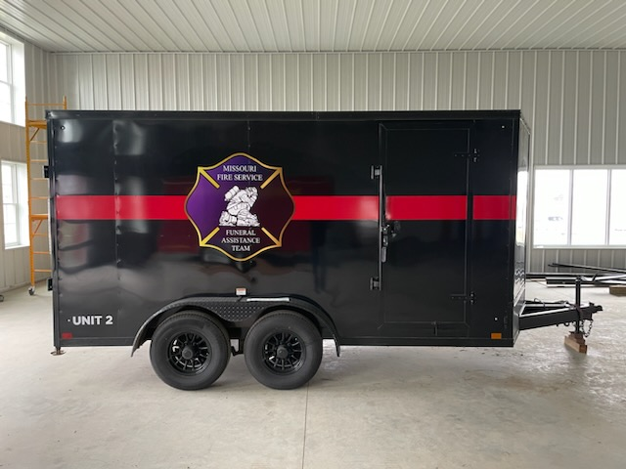

One contains the double staging set and also includes “intermediate steps” as shown below
Traffic Cones
Casket roller box
Portable Radios

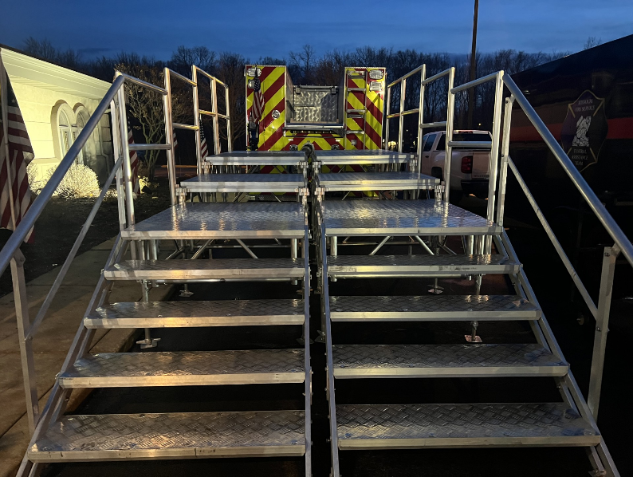

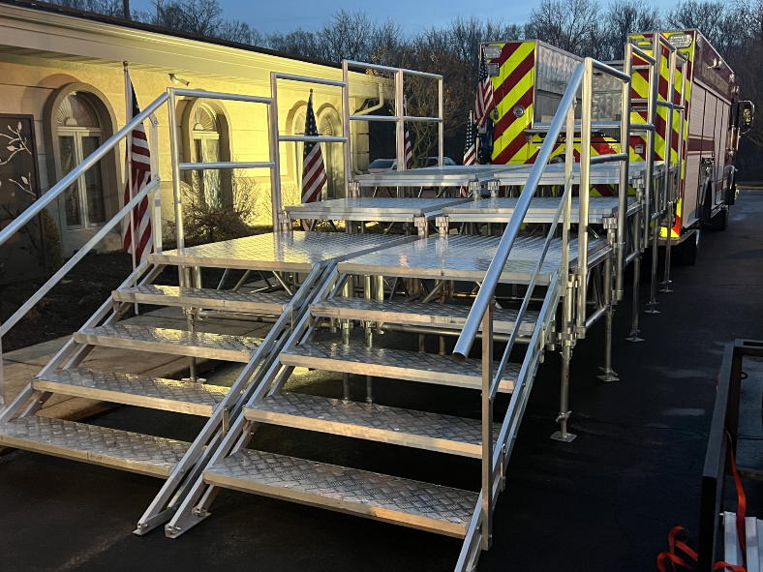

The second contains our large LODD bell and misc supplies.

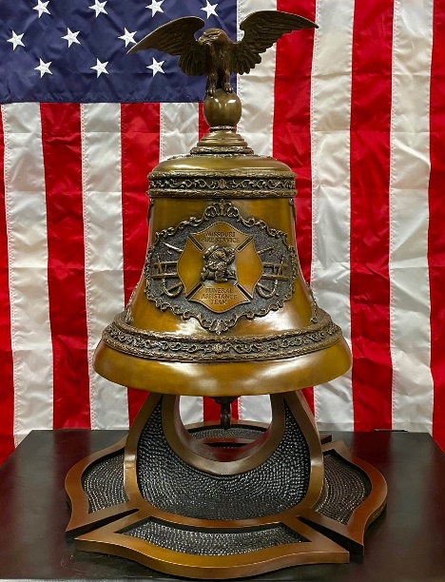
Nebraska
One trailer with flags, bunting, tools, practice casket, signs etc.

New Hampshire
Two trailers
One equipment trailer with the following equipment:

- 2 Sound system
- 3 practice caskets
- Helmets of each color for presentations
- Full set of turnout gear for presentation
- Gear stand
- Podium
- Bell for 555
- Complete set of items for uniform repair
- Ironing board and iron
- Umbrellas
- 2 generators
- 100 dozen white gloves
- Mourning bands
- Bunting
- Black mourning cloths
- Flags
- 20-‘ x 30’ garrison flag
- Banker (people mover chains) for large events
- Backdrops
- Church truck
- Wheel chair
- Trumpet
- Honor guard flags
- Casket flags
- Presentation boxes
- Easels
- Kleenex
- Much more items……

One stage trailer with two 8 x 8 staging systems
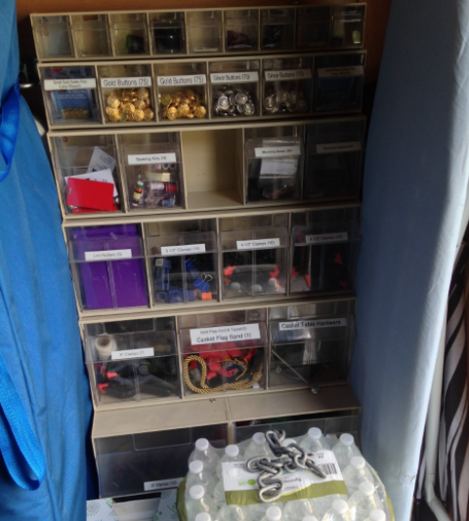
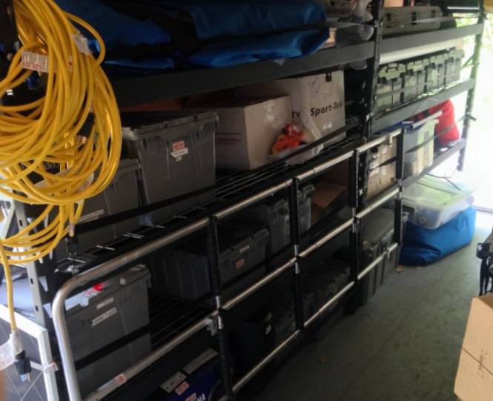
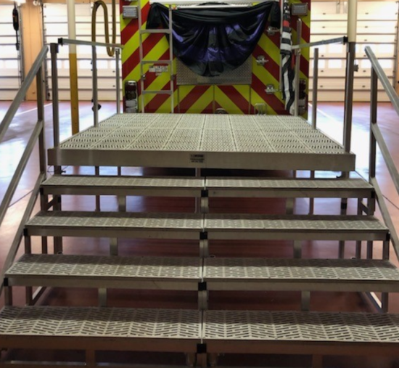
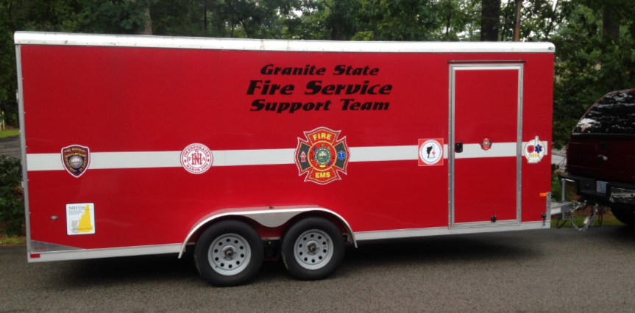
Ohio
One trailer with the following equipment
- Steps and platform for loading a casket on an engine.
- Practice casket
- Bunting for 3 engines
- Rollers Mounted on a plywood sheet that can be put into a hose bed
- Extra hitch ball
- Setup directions
- Extra zip ties

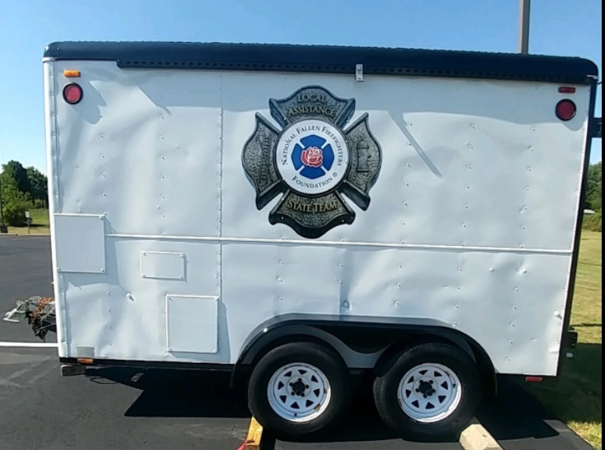

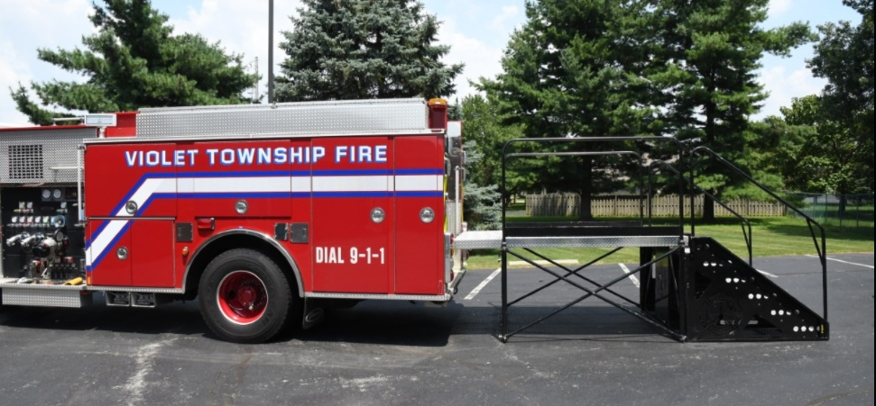

Rhode Island
One trailer with the following equipment
- Steps and platform
- 20+ pieces of bunting
- 1,000+ gloves in various sizes
- Mourning bands
- Several flags
- Axes
- Pike poles
- Bell
- Stand alone PA system and generator

Virginia
One trailer with steps

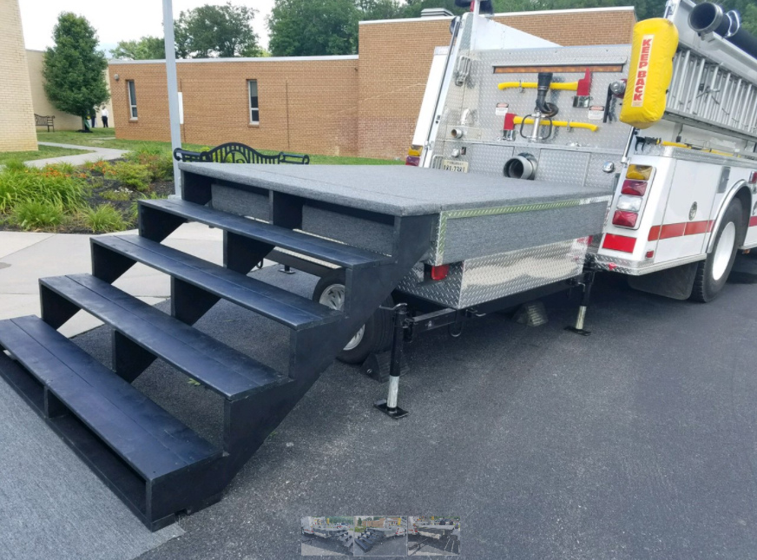
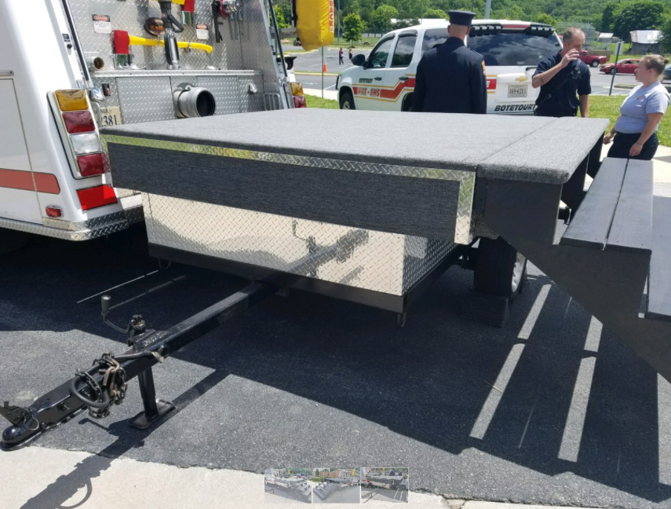
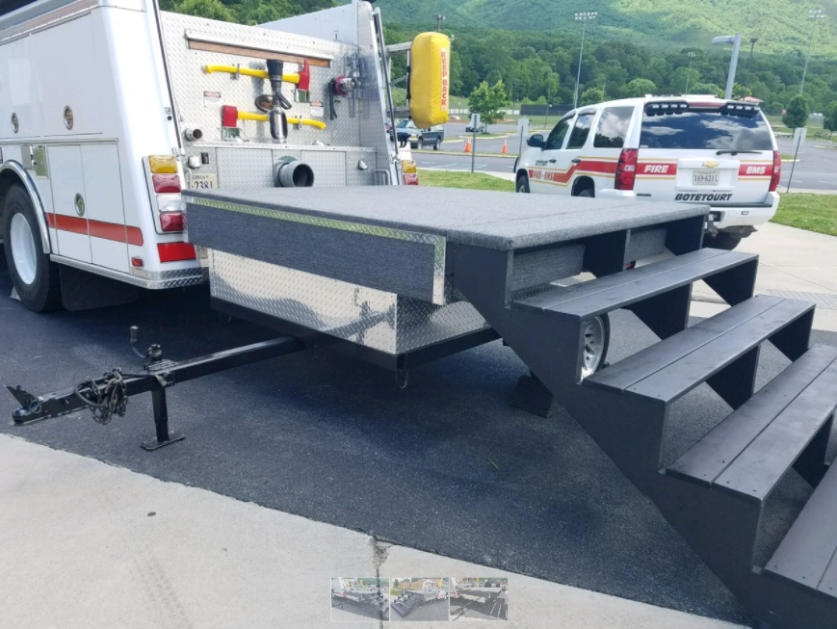

Washington
One trailer with the following equipment:
- Easels
- Table cloths
- Pike poles
- Bell
- Bell table
- Urn table
- Miscellaneous items

West Virginia
- 3 sets of stairs with platforms for loading caskets onto apparatus
- Casket flags kept in fire marshal vehicles

Wyoming
One trailer with the following equipment
- Casket stand and ramp
- Bunting
- 4 – 5 X 9.5 foot cloth flags
- 1 set pike poles (2)
- 1 set axes (2)
- Flag holsters (4)
- Flag toppers: 1 Maltese Cross, 1 Eagle, and 2 Pointed Spear
- Assorted white gloves (box)
- Badge bands
- Casket bands – 2 sets
- Bell
- Table and chairs
- Garment stand
- Candlestick markers (20)
- Garrison Flag – (1) with chord and rope
- 4 flag stand bases and 4 flag poles
- 10 umbrellas
- 2 baskets (for cards)
- 1 urn

